Project 1: Exploring Weather Trends

Course: Data Analysis

Prepper by: Shahad asseri

Date: 4/27/2020

**Project Idea:**

In this project my goal was create a visualization and prepare a describing the similarities and differences between global temperature trends and temperature trends in Riyadh

**Steps taken to prepare the project:**

1-Extract the data from the database by writing SQL query to extract data as CSV file ,the Riyadh data years and avg_temp from city_data table, also the global_data with year column and avg_temp from 1848 to 2013, because the years before 1848 were empty so I try to make everything constant as below:

Figure1: SQL query to extract the Riyadh data

Figure 2: SQL query to extract the Global data

2.a- Open the CSV file in Excel with 5 Columns years, Riyadh avg_temp, Global avg_temp, Global Moving AVG, Riyadh Moving AVG as below:

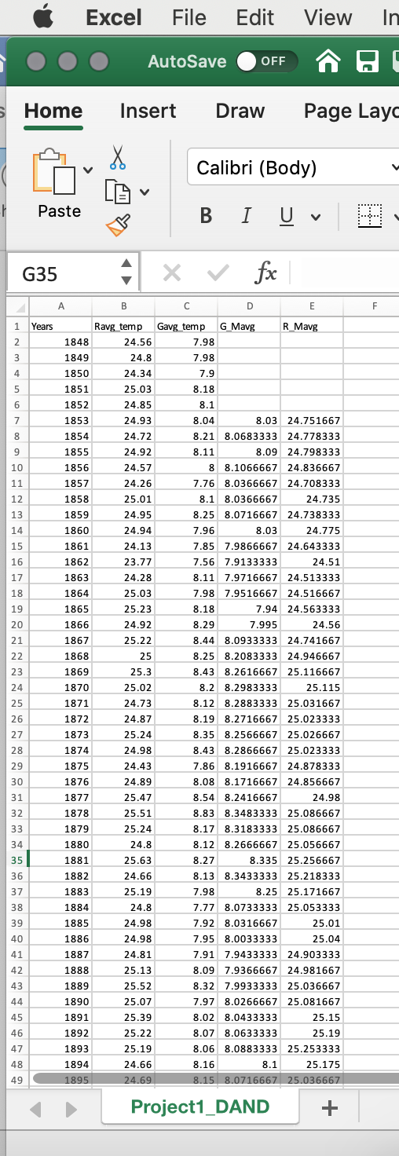

Figure 3: Excel sheet

2.b-I calculate the Moving AVG for every 7 years by using AVG function in Excel as below:

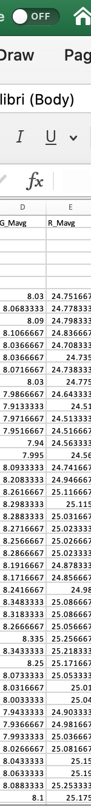

Figure 4: Excel sheet for MOVING AVG

3-crate Line chart and plot the Global and Riyadh moving AVG as below:

Figure 5: Line chart

4- Observations According to line charts, the following observations may be deduced:

* Riyadh's weather is much warmer than the global average considering that the temperature has always been greater in the past couple hundred years.
* In both cases, we can see that the average temperature is gradually increasing throughout the entire timeframe.
* A significant rise in the yearly average temperature can be observed in Riyadh in the past couple of decades starting from the year 1995 upwards.
* The yearly average temperature seems to be increasing abnormally on a global scale in the last 3-4 decades.